FARE ENFORCEMENT SOP: BLOCKED ORCA CARD INSPECTIONS

1.0 PURPOSE:
This directive establishes the Standard Operating Procedure for dealing with blocked ORCA cards by the members of the King County Metro Fare Enforcement Division team. This SOP defines the basics of Blocked ORCA Card Inspection.

2.0 SCOPE:
This directive applies to all King County Metro Fare Enforcement Officers.

3.0 DEFINITIONS:
- Blocked ORCA Card – ORCA card that had been reported lost/stolen or deactivated
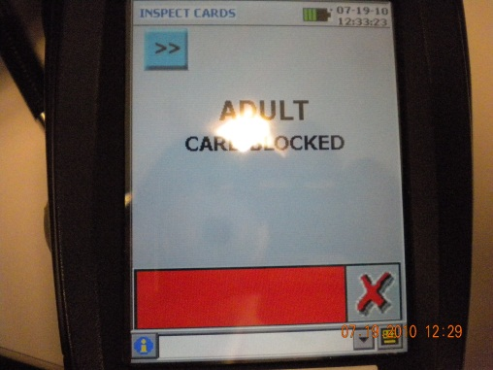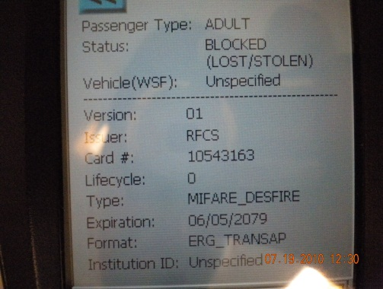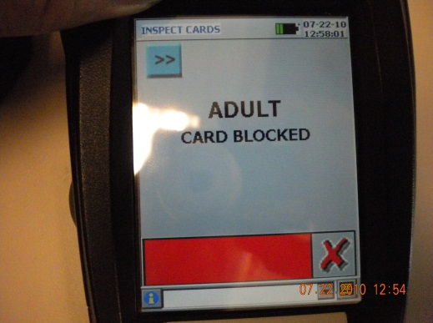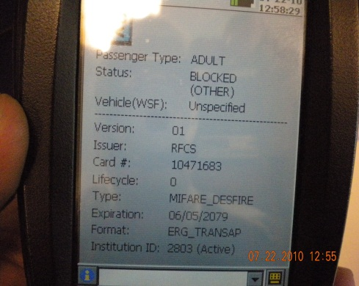

- FEO – Fare Enforcement Officer
- NOI - Notice of Infraction

4.0 POLICY:
It is King County Metro Policy that FEOs are NOT to confiscate any BLOCKED ORCA cards used by a passenger as Proof of Payment.

5.0 BLOCKED ORCA CARDS- FEO Responsibilities
a. FEOs shall check the ORCA card with the hand held reader.
b. If the reader indicates a blocked card, they shall perform an additional check to determine the reason for the card being blocked.
c. FEO’s shall also check the passes on the card. Generally the passes will not be blocked.
d. FEOs shall record the registration number of the blocked ORCA card and determine if a Notice of Infraction (NOI) is to be issued.
e. If the FEO issues a NOI, he/she will note in his/her narrative the card number and what the circumstances were for blocking the card.
f. If the FEO does not issue a NOI, the passengers name will be entered in the Warning Log with an explanation of why a NOI was not issued.

6.0 BLOCKED ORCA CARDS- FE Administrative Responsibilities
- FE Supervisors shall check the NOI to make sure that the card number is included in the narrative of the NOI.

7.0 REVIEW:
The KCM Contract Security Coordinator or Delegate will ensure all Directives, Policies, and Procedures are reviewed at least annually to ensure compliance with King County Metro Security Division policy. Directives, Policies, and Procedures will be updated immediately if division procedure changes or when a facility adds or deletes post positions or procedures and duties.

8.0 SUPERSESSION: All previous Fare Enforcement Manuals.

9.0 EFFECTIVE DATE: 01/15/2015

ISSUING AUTHORITY

___________________

Gail Israelson
KCM Contract Security Coordinator

